A
MINI PROJECT REPORT
On

“Stock visualization-forcasting dashboard”

Submitted to
MIT Art, Design & Technology University
in partial fulfilment of the requirements for the award of the degree of
BACHELOR/MASTER OF TECHNOLOGY
IN
ELECTRONICS AND COMMUNICATION ENGINEERING / ELECTRONICS AND COMPUTER ENGINEERING

Submitted by
Group Code: ECO2324UGMPIV05
Prajakta Deshpande MITU21BTEC0038
Prajakta Narhare MITU21BTEC0039
Shweta Kenjale MITU21BTEC0055
Nikita Singh MITU21BTEC0033

Under the Guidance of
Prof. Dnyaneshwar Kokare



DEPARTMENT OF ELECTRONICS AND COMMUNICATION ENGINEERING
SCHOOL OF ENGINEERING AND SCIENCES, MIT ADT UNIVERSITY
RAJBAUG, LONI KALBHOR, PUNE – 412201

DEPARTMENT OF ELCTRONICS AND COMMUNICATION ENGINEERING
SCHOOL OF ENGINEERING AND SCIENCES,
RAJBAUG, LONI KALBHOR,
PUNE – 412201

CERTIFICATE

This is to certify that the Mini Project report entitled
“Stock visualization-forcasting dashboard”
Submitted by

Prajakta Deshpande MITU21BTEC0038
Prajakta Narhare MITU21BTEC0039
Shweta Kenjale MITU21BTEC0055
Nikita Singh MITU21BTEC0033

is a bonafide work carried out by them, under the supervision of Prof. Dnyaneshwar Kokare and it is submitted towards the partial fulfilment of the requirement of MIT Art, Design and Technological University, Pune for the award of the Bachelor of Technology in Electronics and Computer Engineering.

Prof. Dnyaneshwar Kokare  Guide | Prof. Mahesh Kamthe  Mini-Project Co-ordinator
Prof. Dr. Shubhangi Joshi  I/c HoD, ECE Dept. | Prof. Dr. Virendra Shete  Director

Chairperson / Examiner

Place: Loni Kalbhor, Pune
Date: 08/05/2024

DECLARATION
We hereby declare that the Mini project entitled “Stock visualization-forcasting dashboard” submitted towards the partial fulfilment of the requirement of MIT-ADT University, Pune for the award of the Bachelor of Technology in Electronics and Computer Engineering is a record of bonafide work carried out by we under the supervision of Prof. Dnyaneshwar Kokare, Department of Electronics and Communication Engineering, School of Engineering and Sciences.
We further declare that the work reported in this report has not been submitted and will not be submitted, either in part or in full, for the award of any other degree or diploma in this institute or any other institute or university.

Place: Loni Kalbhor, Pune Student Names and Sign
Date: 08/05/2024 Prajakta Deshpande
Prajakta Narhare
Shweta Kenjale Nikita Singh

ACKNOWLEDGEMENT

We express our profound thanks to Guide Prof. Dnyaneshwar Kokare, Electronics and Communication Engineering, School of Engineering and Sciences MIT-ADT University, Pune for his/her expert guidance, encouragement and inspiration during this Mini project work.
We are very thankful Prof. Dr. Sachin Takale, Mini-Project Co-ordinator, Electronics and Communication Engineering Department for his/her guidance and all kinds of help to complete my/our work.
We also express thanks to Prof. Dr. Shubhangi Joshi, I/c Head, Department of Electronics and Communication Engineering, for being constant source of inspiration throughout the execution.
We are grateful to Prof. Dr. Virendra Shete, Director, School of Engineering and Sciences, MIT-ADT University, Pune, for providing us the facilities to carry out this work.
We also thank all the faculty members in the department for their support and advice. We are very much grateful to our Parents for their immense love, affection, help, cooperation and encouragement to complete this course.
Finally, a special thanks to all our classmates and friends who helped and encouraged us to complete successfully our Mini project work.

Student Name

Prajakta Deshpande
Prajakta Narhare
Shweta Kenjale Nikita Singh

ABSTRACT
In the finance world stock trading is one of the most important activities. Stock market prediction is an act of trying to determine the future value of a stock other financial instrument traded on a financial exchange. This paper explains the prediction of a stock using Machine Learning. The technical and fundamental or the time series analysis is used by the most of the stockbrokers while making the stock predictions. The programming language is used to predict the stock market using machine learning is Python. In this paper we propose a Machine Learning (ML) approach that will be trained from the available stocks data and gain intelligence and then uses the acquired knowledge for an accurate prediction.. In today's fast-paced financial markets, accurate stock price forecasting is essential for investors, traders, and financial analysts. Deep learning techniques, particularly Long Short-Term Memory (LSTM) neural networks, have shown promising results in capturing the complex temporal dependencies present in stock market data. In this study, we propose a comprehensive stock visualization and forecasting dashboard powered by LSTM neural networks. The dashboard integrates real-time stock data retrieval, preprocessing, visualization, and forecasting capabilities into a user-friendly interface. Users can input desired stock symbols and specify the forecasting horizon. The system then retrieves historical stock price data from a reliable financial data source and preprocesses it to remove noise and ensure data quality. The heart of the dashboard lies in the LSTM neural network model, which learns the underlying patterns and trends from historical stock price data. The model's architecture is optimized to effectively capture both short-term fluctuations and long-term trends in the stock prices. Through extensive training on historical data, the LSTM model becomes adept at identifying intricate patterns and making accurate predictions. The dashboard provides intuitive visualizations of historical stock prices, including candlestick charts, moving averages, and volume analysis. Furthermore, the forecasting module leverages the trained LSTM model to predict future stock prices based on the input parameters provided by the user. Overall, the proposed stock visualization and forecasting dashboard offers a powerful tool for investors and financial professionals to analyze historical trends, make informed decisions, and optimize their trading strategies in today's dynamic stock market environment.

PHOTOGRAPH OF THE PROJECT
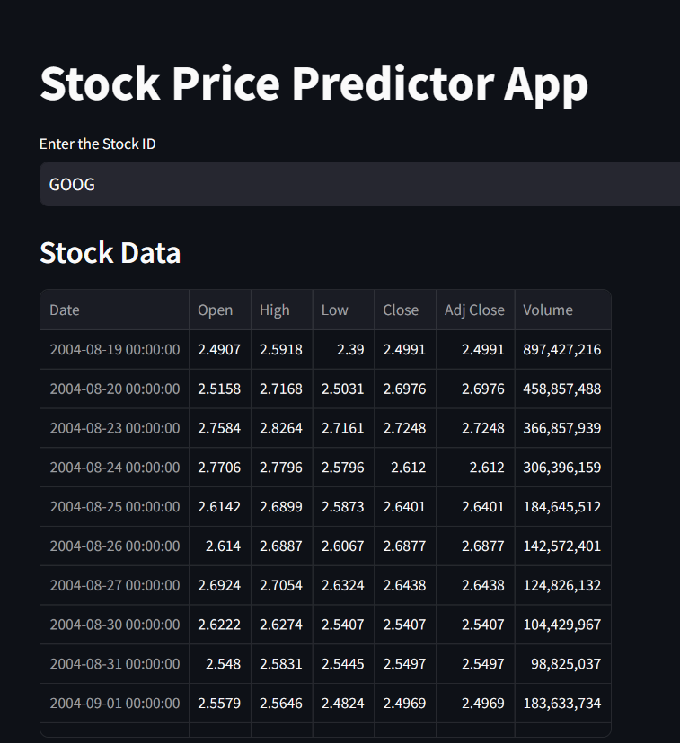
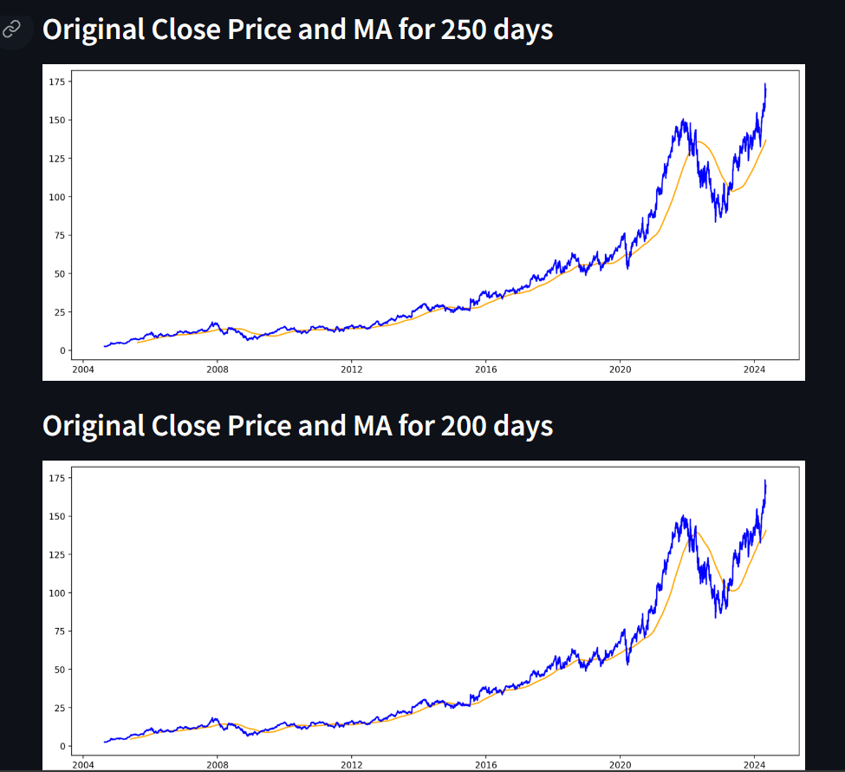

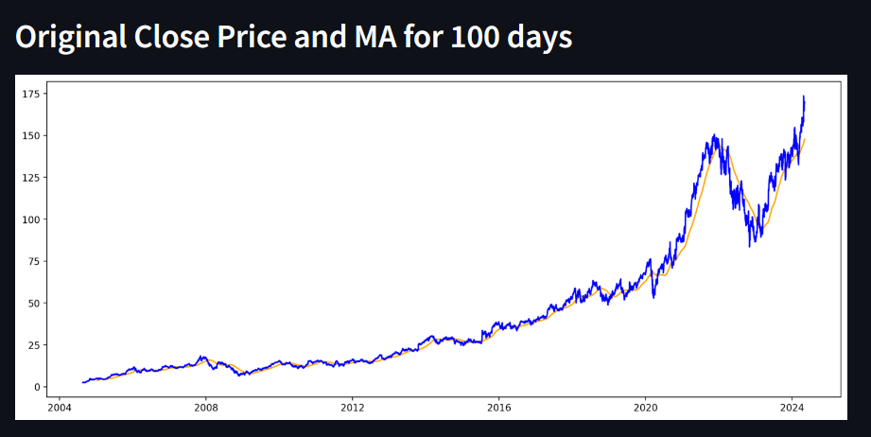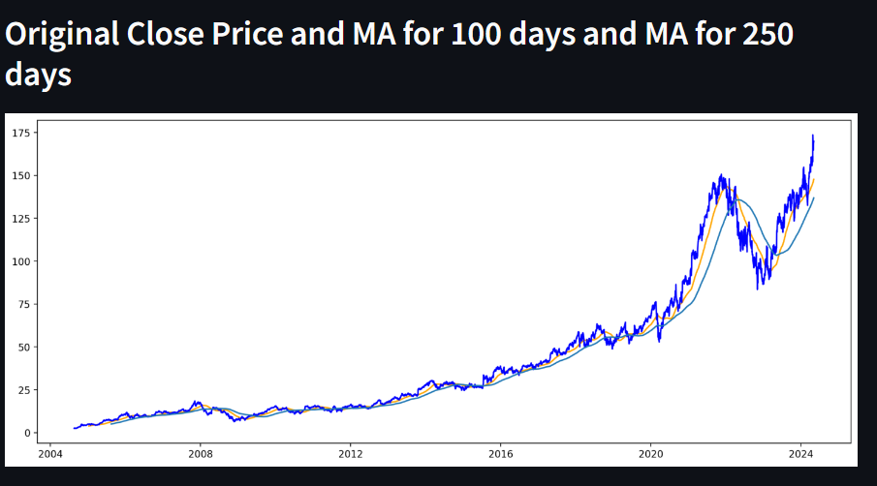

LIST OF DIAGRAMS
Dig. No. | Name of the Figure | Page No.
3.1 | Block diagram | 5

TABLE OF CONTENTS

ABSTRACT i
PHOTOGRAPH OF THE PROJECT ii
LIST OF DIAGRAM iii
Chapter 1 1
INTRODUCTION 1
1.1 Introduction 1
Chapter 2 2
LITERATURE REVIEW 2
2.1 Introduction 2
2.2. Review of literature 2
2.3 Summary of the literature 2
2.4 Identification of Gaps/Scopes of Work 3
2.5 Closure 3
Chapter 3 4
METHODOLOGY 4
3.3 Block Diagram 5
3.4 Closure 5
CHAPTER 4 5
RESULTS AND DISCUSSIONS 6
4.1 Result and Discussion 6
4.2 Code 10
CHAPTER 5 11
CONCLUSION AND FUTURE SCOPE 11
5.1 Conclusion 11
5.2 Future Scope 11
APPENDIX I 12
COST SHEET 12
APPENDIX III 13
PROJECT BASED OUTCOMES 13

LIST OF DIAGRAM
Dia. No. | Name of the Figure | Page No.
3.1 | Block diagram | 5

Chapter 1

INTRODUCTION

1.1 Introduction
Basically, quantitative traders with a lot of money from stock markets buy stocks derivatives and equities at a cheap price and later on selling them at high price. The trend in a stock market prediction is not a new thing and yet this issue is kept being discussed by various organizations. There are two types to analyse stocks which investors perform before investing in a stock, first is the fundamental analysis, in this analysis investors look at the intrinsic value of stocks, and performance of the industry, economy, political climate etc. to decide that whether to invest or not. On the other hand, the technical analysis it is an evolution of stocks by the means of studying the statistics generated by market activity, such as past prices and volumes. In the recent years, increasing prominence of machine learning in various industries has enlightened many traders to apply machine learning techniques to the field, and some of them have produced quite promising results. This paper will develop a financial data predictor program in which there will be a dataset storing all historical stock prices and data will be treated as training sets for the program. The main purpose of the prediction is to reduce uncertainty associated to investment decision making. Stock Market follows the random walk, which implies that the best prediction you can have about tomorrow’s value is today’s value. Indisputably, the forecasting stock indices are very difficult because of the market volatility that needs accurate forecast model. The stock market indices are highly fluctuating and it effects the investor’s belief. Stock prices are considered to be a very dynamic and susceptible to quick changes because of underlying nature of the financial domain and in part because of the mix of a known parameters (Previous day’s closing price, P/E ratio etc.) and the unknown factors (like Election Results, Rumors etc.). There have been numerous attempts to predict stock price with Machine Learning.

Chapter 2

LITERATURE REVIEW

2.1 Introduction
Stock market is trading platform where different investors sale and purchase shares according to stock availability. The growth of the amount of stock data generated every day is difficult to predict. The price trend in the stock market is uncertain, and the valuable information hidden in the stock data is difficult to detect. Developing this simple project idea using the Dash library (of Python), we can make dynamic plots of the financial data of a specific company by using the tabular data provided by yfinance python library. On top of it, we can use a machine learning algorithm to predict the upcoming stock prices.

2.2. Review of literature
The literature on stock visualization and forecasting encompasses a broad range of approaches, methodologies, and findings. Traditional methods, such as time series analysis and econometric models, have long been employed to forecast stock prices. However, recent advancements in machine learning and data visualization techniques have led to the exploration of more sophisticated approaches, including deep learning models, sentiment analysis of news and social media, and network analysis of financial markets. Studies have highlighted the importance of incorporating non-linear patterns and high-frequency data in forecasting models, while also emphasizing the significance of interpretability and transparency in visualization techniques for investors and analysts. Despite the progress made, challenges remain in accurately capturing market dynamics, especially during periods of extreme volatility or structural shifts, warranting further research into hybrid models and novel visualization techniques that can effectively capture the complexities of financial markets.
Top of Form
2.3 Summary of the literature
In summary, the literature review reveals a stock analysis is the evaluation of a particular trading instrument, an investment sector, or the market as a whole. Stock analysts attempt to determine the future activity of an instrument, sector, or market.

2.4 Identification of Gaps/Scopes of Work
Building upon the existing literature, this research aims to address the identified gaps by:
1. Examining existing visualization tools and platforms would help pinpoint any deficiencies in terms of data representation, interactivity, or comprehensibility.
2. Understanding the specific requirements and preferences of users, such as investors, analysts, and traders, is crucial.
3. Conducting a comparative analysis of competing products and solutions can highlight areas where innovation is lacking or where improvements can be made.
Furthermore, exploring emerging technologies and trends in data visualization and predictive analytics, such as augmented reality (AR) visualization or blockchain-based forecasting models, can uncover novel approaches to address existing gaps in stock visualization and forecasting. Overall, by systematically analyzing existing solutions, user requirements, competitor offerings, and emerging technologies, the gaps and scopes of work for stock visualization and forecasting can be clearly identified, providing a roadmap for the development of a more advanced and comprehensive solution.

2.5 Closure
In next chapter we cover methodology of this project in detail.

Chapter 3

METHODOLOGY

3.1 Introduction
This project involves Investment companies and individual investors have been utilizing money models to possess a higher understanding of the market and build a profitable investment. Plenty of data regarding stock data fluctuations is at hand for analysis and processing. Investors take calculated guesses by analyzing data. This seeks to utilize Deep Learning models, LSTM Neural Networks, to predict stock costs.

3.2 Methodology Details
While working on the use the machine learning in the prediction of stock market the different types of the neural network can be proposed for prediction. Here we are using Long short -term memory (LSTM) which is an artificial recurrent neural network (RNN).
A. Recurrent Neural Network
A recurrent neural network (RNN) is a part of artificial neural network. RNN uses the sequential data or time series data. RNN works on principle of saving the output of the specific layer and feeding this back to the input in order to forecast the output of the layer. The most important characteristic of the Recurrent neural network is hidden state, which consider data about sequence.
B. Long Short-Term Memory (LSTM):
The Long Short-Term Memory is a special type of RNN, it is efficient of catching the data from previous Stages and use it for upcoming future predication. LSTMs are widely used for sequence prediction problems and have proven to be extremely successful. The reason behind is they work so well is because LSTM is able to store historic information that is important and forget the information that is not. LSTM has three gates:
The input gate: The input gate adds details to the cell state.
The forget gate: It removes the details that is no longer required by the model.
The output gate: Output Gate at LSTM selects the details to be shown as output

3.3 Block Diagram
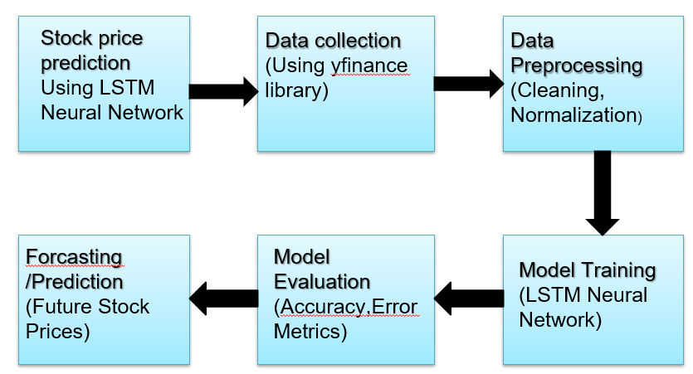
3.1 Block dig.
3.4 Closure
In next chapter we cover conclusion and final result of the project.

CHAPTER 4

RESULTS AND DISCUSSIONS

Result:

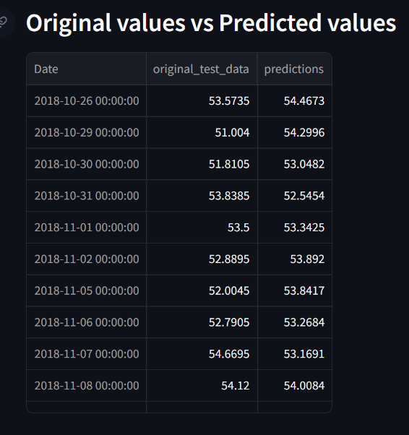

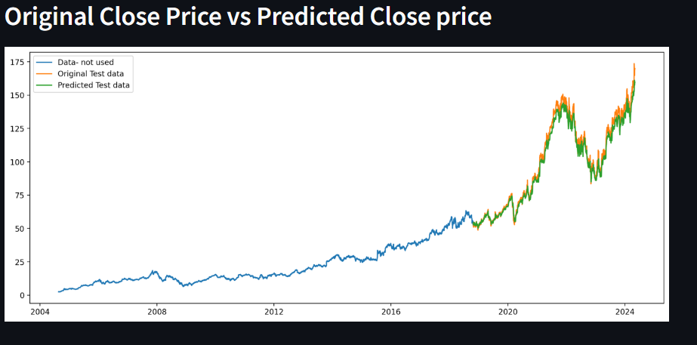

Discussion:
After getting the relative stock data hundred days moving average and two-hundred days moving average is calculated to predict the closing price of the particular share over the given period. The machine Learning model takes the hundred days moving average and two hundred moving average and predict the stock price for selected time period. The model takes first hundred days price and predict the next day price. By using the moving averages LSTM predict stock price. The prediction accuracy of the LSTM model improves with increase in the size of the dataset and makes is more efficient.

Code used:
// !pip install
import yfinance as yf
from datetime import datetime
end = datetime.now()
start = datetime(end.year-20, end.month, end.day)
stock = "GOOG"
google_data = yf.download(stock, start, end)
google_data.head()
google_data.shape
google_data.describe()
google_data.info()
google_data.isna().sum()
import matplotlib.pyplot as plt
%matplotlib inline
plt.figure(figsize = (15,5))
google_data['Adj Close'].plot()
plt.xlabel("years")
plt.ylabel("Adj Close")
plt.title("Closing price of Google data")
def plot_graph(figsize, values, column_name):
plt.figure()
values.plot(figsize = figsize)
plt.xlabel("years")
plt.ylabel(column_name)
plt.title(f"{column_name} of Google data")
google_data.columns
for column in google_data.columns:
plot_graph((15,5),google_data[column], column)
temp_data = [10, 20, 30, 40, 50, 60, 70, 80, 90, 100]
print(sum(temp_data[1:6])/5)
import pandas as pd
data = pd.DataFrame([10, 20, 30, 40, 50, 60, 70, 80, 90, 100])
data.head()
data['MA'] = data.rolling(5).mean()
data
for i in range(2004,2025):
print(i,list(google_data.index.year).count(i))
google_data['MA_for_250_days'] = google_data['Adj Close'].rolling(250).mean()
google_data['MA_for_250_days'][0:250].tail()
plot_graph((15,5), google_data['MA_for_250_days'], 'MA_for_250_days')
plot_graph((15,5), google_data[['Adj Close','MA_for_250_days']], 'MA_for_250_days')
google_data['MA_for_100_days'] = google_data['Adj Close'].rolling(100).mean()
plot_graph((15,5), google_data[['Adj Close','MA_for_100_days']], 'MA_for_100_days')
plot_graph((15,5), google_data[['Adj Close','MA_for_100_days', 'MA_for_250_days']], 'MA')
google_data['percentage_change_cp'] = google_data['Adj Close'].pct_change()
google_data[['Adj Close','percentage_change_cp']].head()
plot_graph((15,5), google_data['percentage_change_cp'], 'percentage_change')
Adj_close_price = google_data[['Adj Close']]
max(Adj_close_price.values),min(Adj_close_price.values)
from sklearn.preprocessing import MinMaxScaler
scaler = MinMaxScaler(feature_range=(0,1))
scaled_data = scaler.fit_transform(Adj_close_price)
scaled_data
len(scaled_data)
x_data = []
y_data = []

for i in range(100, len(scaled_data)):
x_data.append(scaled_data[i-100:i])
y_data.append(scaled_data[i])

import numpy as np
x_data, y_data = np.array(x_data), np.array(y_data)
x_data[0],y_data[0]

int(len(x_data)*0.7)
4908-100-int(len(x_data)*0.7)
splitting_len = int(len(x_data)*0.7)
x_train = x_data[:splitting_len]
y_train = y_data[:splitting_len]
x_test = x_data[splitting_len:]
y_test = y_data[splitting_len:]
print(x_train.shape)
print(y_train.shape)
print(x_test.shape)
print(y_test.shape)
!pip install Tensorflow
from keras.models import Sequential
from keras.layers import Dense, LSTM
model = Sequential()
model.add(LSTM(128, return_sequences=True, input_shape=(x_train.shape[1],1)))
model.add(LSTM(64,return_sequences=False))
model.add(Dense(25))
model.add(Dense(1))
model.compile(optimizer='adam', loss='mean_squared_error')
model.fit(x_train, y_train, batch_size=1, epochs = 2)
model.summary()
predictions = model.predict(x_test)
predictions
inv_predictions = scaler.inverse_transform(predictions)
inv_predictions
inv_y_test = scaler.inverse_transform(y_test)
inv_y_test
rmse = np.sqrt(np.mean( (inv_predictions - inv_y_test)**2))
rmse
ploting_data = pd.DataFrame(
{
'original_test_data': inv_y_test.reshape(-1),
'predictions': inv_predictions.reshape(-1)
} ,
index = google_data.index[splitting_len+100:]
)
ploting_data.head()
plot_graph((15,6), ploting_data, 'test data')
plot_graph((15,6), pd.concat([Adj_close_price[:splitting_len+100],ploting_data], axis=0), 'whole data')
model.save("Latest_stock_price_model.keras")//

CHAPTER 5

CONCLUSION AND FUTURE SCOPE

5.1 Conclusion
In conclusion, Predicting the stock market is a time-consuming and arduous procedure. However, with the introduction to Machine Learning and its various algorithms, the Stock Market Prediction advancements have begun to consist such approaches in considering stock market data. By calculating the accuracy of the different type of algorithms, we found that the most appropriate algorithm for predicting the market price of a stock based on various data points from the previous past data is the Long-Short Term Memory (LSTM) algorithm.
The algorithm will be a great asset for brokers and investors for investing money in the stock market since it is trained on a vast collection of historical data and has been chosen after being tested on a trial data. The project demonstrates the machine learning model to predict the stock price with more accuracy as compared to other machine learning models. The sentiment analysis of social media can be used with the LSTM to better train weights and further improve machine learning model. It has led to the conclusion that it is possible to predict the stock market with more accuracy and efficiency using machine learning techniques.
5.2 Future scope:
Future scope of this project is visualizing and forecasting stock has a very huge in the field of stock market. According to recent report the number of investors investing in stock market is increasing every year, therefore a system of visualizing and forecasting stocks is required to guide the investors to invest carefully in the stocks. Visualizing stocks is a risky trend and can often lead to inaccurate value predictions mainly because of how many factors it depends upon. This project can be extended and modified in future by training the model on more features and including some important nonnumerical features as well with the help of a subject matter expert.

APPENDIX I
COST SHEET
Sr. No. | Particular | Amount (Rs.)
Total |  | 0

APPENDIX III

PROJECT BASED OUTCOMES
The student needs to fill the below table for the outcomes they have gained during the work. These outcomes will vary based on project-based learnings.
Outcomes | Agree  (1) | Moderately  (2) | Highly Agree (3)
1. Engineering knowledge: Apply the knowledge of mathematics science engineering fundamentals and an mathematics, science, engineering fundamentals, and an engineering specialization to the solution of complex engineering problems engineering problems.
2. Problem analysis: Identify, formulate, review research literature, and analyze complex engineering problems reaching substantiated conclusions using first principles of mathematics, natural sciences, and engineering sciences.
3. Design/development of solutions: Design solutions for complex engineering problems and design system components or processes that meet the specified needs with appropriate consideration for the public health and safety, and the cultural, societal, and environmental considerations
4. Conduct investigations of complex problems: Use research-based knowledge and research methods including design of experiments, analysis and interpretation of data, and synthesis of the information to provide valid conclusions
5. Modern tool usage: Create, , select, and apply appropriate techniques, resources, and modern engineering and IT tools including and modeling to complex engineering activities with an understanding of the limitations
6. The engineer and society: Apply reasoning informed by Apply reasoning informed by the contextual knowledge to assess societal, health, safety, legal and cultural issues and the consequent responsibilities legal and cultural issues and the consequent responsibilities relevant to the professional engineering practice
7. Environment and sustainability: Understand the impact of the professional engineering solutions in societal and environmental contexts, and demonstrate the knowledge of, and need for sustainable development and need for sustainable development.
8. Ethics: Apply ethical principles and commit to professional ethics and responsibilities and norms of the engineering practice
9. Individual and team work: Function effectively as an individual and as a member or leader in diverse teams and individual, and as a member or leader in diverse teams, and in multidisciplinary settings
10. Communication: Communicate effectively on complex engineering activities with the engineering community and with society at large, such as, being able to comprehend and write effective reports and design documentation, and write effective reports and design documentation, make effective presentations, and give and receive clear instructions
11. Project management and finance: Demonstrate knowledge and understanding of the engineering and knowledge and understanding of the engineering and management principles and apply these to one’s own work, as a member and leader in a team, to manage projects and in multidisciplinary environments.
12. Life-long learning: Recognize the need for and have the Recognize the need for, and have the preparation and ability to engage in independent and lifelong learning in the broadest context of technological change

